MEDICORE HEALTH
Patient Visit Analytics

SURYA ANTARVEDI
24-07-2026

Data Cleaning Summary
The raw export (medicore_raw.csv) contained 13,453 patient-visit rows. After cleaning, the working dataset has 10,872 rows. Key corrections made before analysis:
- 1,441 duplicate visit rows removed (caused by a sync glitch between the Hospital Information System and the billing system).
- Missing values imputed: patient_age (271 rows), length_of_stay (413), billing_amount (536), insurance_type (331), satisfaction_score (811) - median for the skewed numeric fields, mode for the categorical ones.
- 36 negative patient_age values (e.g. -3) and 248 negative length_of_stay values corrected using the absolute value, rather than removed.
- 85 impossible patient ages (130, 140 and 180 years) identified using the Z-score method and removed as outliers.
- 884 length_of_stay outliers removed using the IQR method - many were exact multiples of 15 days (30, 45, 60 ... 300), a pattern consistent with a data-entry multiplier error rather than genuine extended stays.
- 171 billing_amount outliers removed using the IQR method (bills far above the typical range for a visit).
- satisfaction_score was left as-is: it is a fixed 1-5 rating scale, so every recorded value is valid and none qualify as an outlier.
- Text fields standardized (casing, whitespace) for department and city, and admission dates unified from two source formats (ISO and DD/MM/YYYY) into one datetime column.
All downstream figures below are based on this cleaned dataset (10,872 visits, 2,993 unique patients, Jan 2024 - Dec 2025).

Overall Patient Volume and Revenue
Total revenue across the two-year window is approximately Rs 34.42 crore (Rs 344,210,955) from 10,872 visits, at an average billing amount of roughly Rs 31,660 per visit.
Unlike a retail sales pattern, patient volume and revenue are stable month-over-month, with no strong seasonal spike. Monthly visits range narrowly between about 420 and 490, and monthly revenue stays within a band of roughly Rs 130-160 lakh throughout both 2024 and 2025. This is consistent with a hospital network serving fairly constant underlying demand for care, rather than discretionary, event-driven spending.
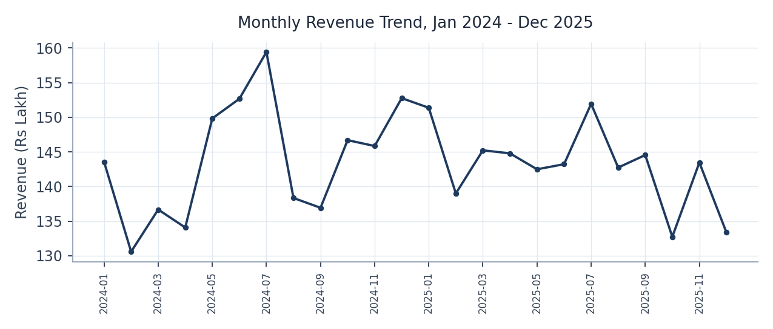
Monthly revenue trend, Jan 2024 - Dec 2025

Department and Region Performance
Cardiology (Rs 936.7 lakh) and Orthopedics (Rs 816.0 lakh) are the two leading revenue departments, together contributing well over half of total revenue. Oncology follows at Rs 638.8 lakh, with Emergency (Rs 419.8 lakh) and General Medicine (Rs 406.9 lakh) close behind. Pediatrics generates the least revenue of the six departments, at Rs 223.9 lakh.
By region, revenue is tightly clustered: North is highest (Rs 886.7 lakh) and South is lowest (Rs 841.5 lakh) - a spread of under 6% between the strongest and weakest region. No single region is materially under- or over-performing relative to the others.
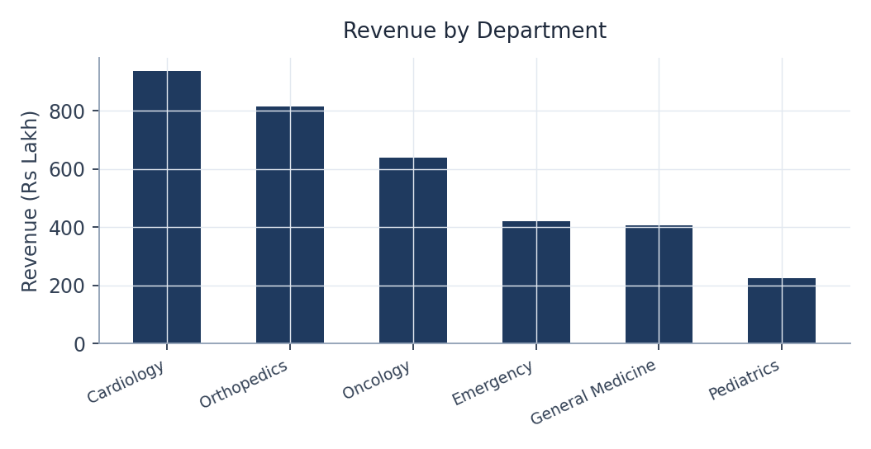
Revenue by department
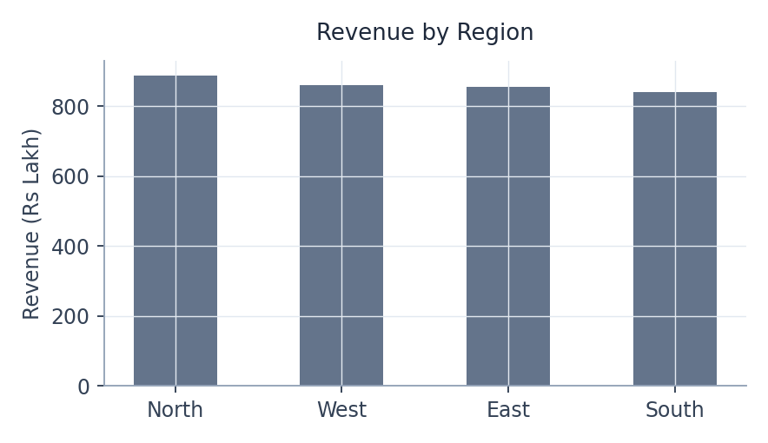
Revenue by region

Length of Stay: Emergency vs Scheduled
Normality and equal-variance checks both failed (Shapiro-Wilk p < 0.001 for each group, Levene's p < 0.001), so a Mann-Whitney U test was used. The result is highly significant (U = 9,423,035.5, p < 0.001): length of stay does differ between Emergency and Scheduled admissions.
The direction is worth calling out: Emergency admissions have a shorter stay (median 2 days, mean 2.81) than Scheduled admissions (median 3 days, mean 3.45) - the opposite of what is usually assumed. Scheduled patients, not Emergency patients, are the ones running the longer stays in this dataset.
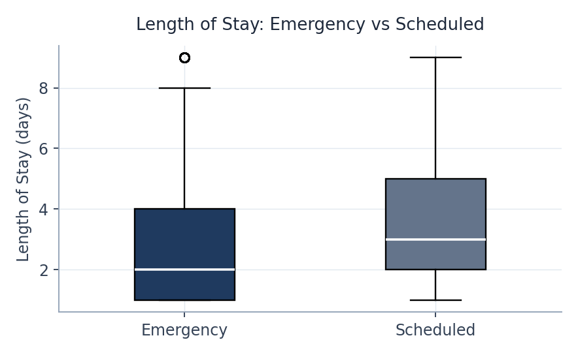
Length of stay: Emergency vs Scheduled admissions

Length of Stay Across Departments
A Kruskal-Wallis test (used after normality and equal-variance assumptions both failed) found a highly significant difference in length of stay across departments (H = 3210.2, p < 0.001).
Oncology has the longest average stay (5.03 days), followed by Cardiology (4.68) and Orthopedics (4.17). Emergency and Pediatrics have the shortest average stays (2.16 days each), with General Medicine close behind (2.60).
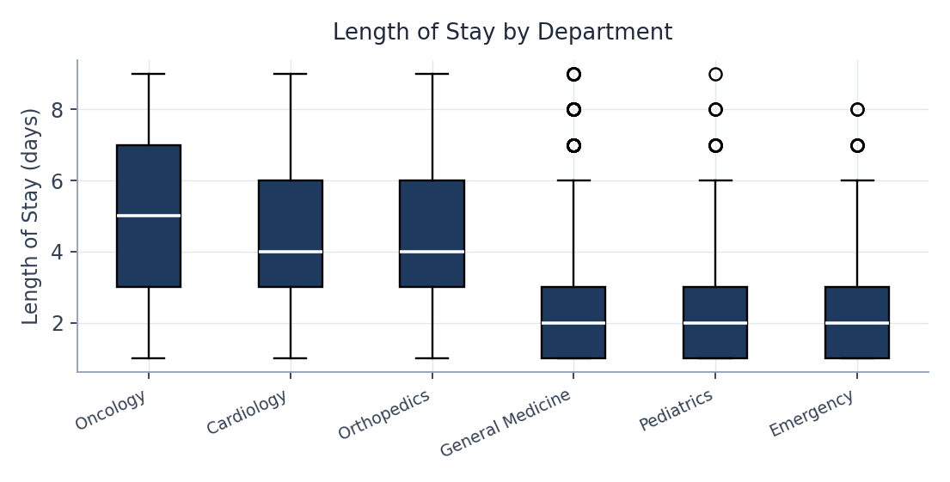
Length of stay by department

Department vs Readmission
A chi-square test of independence found a highly significant association between department and readmission (chi-square = 126.14, p < 0.001, df = 5). Readmission rates by department:
- Oncology: 22.8%
- Cardiology: 22.0%
- Emergency: 15.9%
- Orthopedics: 13.6%
- General Medicine: 13.0%
- Pediatrics: 12.1%
Oncology and Cardiology are simultaneously two of the top revenue-generating departments (Section 3) and the two departments with the highest readmission rates, roughly 1.5-2x the rest of the network - this is the clearest quality-of-care priority in the dataset.
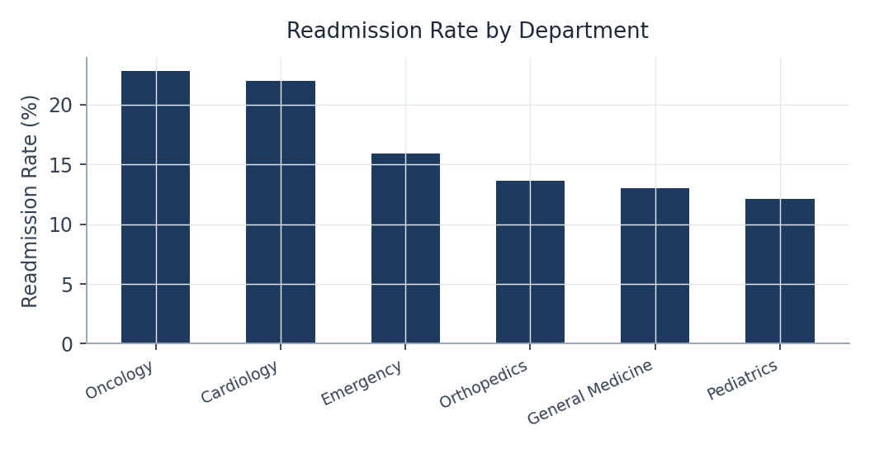
Readmission rate by department

Insurance Type vs Billing Amount
A Kruskal-Walli’s test (used after normality and equal-variance assumptions both failed) found no statistically significant difference in billing amount across insurance types (H = 1.23, p = 0.745).
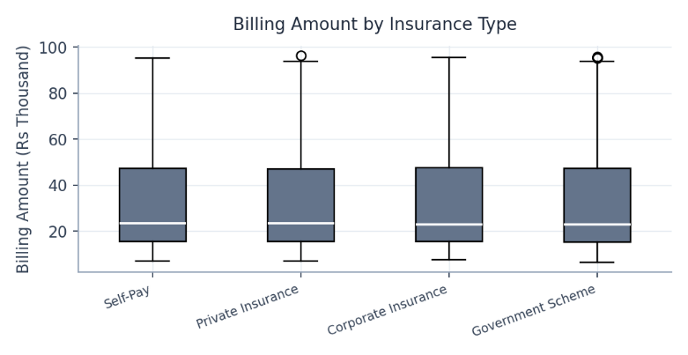
Average billing is nearly identical across all four insurance types, from Rs 31,465 (Government Scheme) to Rs 31,940 (Self-Pay) - a spread of under 2%. Pricing is being applied consistently regardless of payer; the cost variation seen elsewhere in this report is coming from department and length of stay, not insurance type.

Billing amount by insurance type

Patient Segments and Revenue
The 36-50 age group drives both the most admissions (3,709) and the most revenue (Rs 11.89 crore), ahead of 51-65 (Rs 8.35 crore), 19-35 (Rs 7.46 crore), 66+ (Rs 4.02 crore) and 0-18, which contributes the least (Rs 2.71 crore).
By gender, admissions and revenue are fairly balanced: Male patients account for 5,596 admissions and Rs 17.56 crore in revenue, versus 5,276 admissions and Rs 16.86 crore for Female patients - a gap of roughly 4%, far smaller than the spread across age groups.
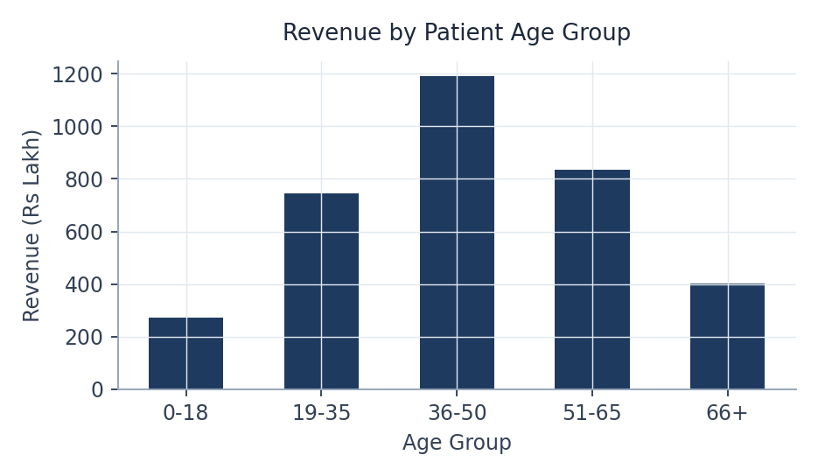
Revenue by patient age group

Readmission Rates and Satisfaction
Patients who are readmitted report meaningfully lower satisfaction (average 3.51) than patients who are not readmitted (average 4.45). Combined with Section 6, this shows readmission is not just a cost and capacity problem - it is directly hurting the patient experience score, and Oncology and Cardiology are the two departments where this shows up most.

Length of Stay vs Billing Amount and Satisfaction
Length of stay and billing amount are strongly, positively correlated (Spearman rho = 0.606, p < 0.001) - longer stays reliably cost more, as expected.
Length of stay and satisfaction score are moderately, negatively correlated (Spearman rho = -0.337, p < 0.001) - longer stays are associated with lower reported satisfaction, reinforcing the point made in Section 9 that length of stay is a patient-experience lever as well as a cost one.

Role-Specific Recommendations

Hospital Operations
- Weight bed and staffing allocation toward Oncology, Cardiology and Orthopedics, since these three departments run 4–5-day average stays versus roughly 2 days in Emergency and Pediatrics (Section 5).
- Review discharge planning and bed turnover for Scheduled admissions specifically - they run a longer stay than Emergency admissions (median 3 vs 2 days, Section 4), which runs counter to the usual assumption and is worth investigating directly.
- Treat length-of-stay reduction as a direct cost lever, not just an experience one: length of stay and billing amount are strongly correlated (rho = 0.61, Section 10).
- Plan capacity on a steady-state basis rather than building in seasonal buffers - patient volume and revenue are stable month-over-month across both years on record (Section 2).

Department Heads
- Prioritize Cardiology and Oncology for readmission-reduction work - they are simultaneously the top two revenue-generating departments and the two departments with the highest readmission rates (22.0% and 22.8%, Section 6).
- Do not look to insurance type as a source of billing variation - amounts are consistent across all four payer types (p = 0.745, Section 7); department and length of stay are the real drivers of cost.
- Tune staffing schedules and follow-up protocols around the 36-50 age group, since it accounts for the largest share of both admissions and revenue by a wide margin (Section 8).
- Review whether Pediatrics' lower revenue (Section 3) reflects genuine lower demand or an opportunity to grow this service line.

Quality of Care
- Co-own readmission-reduction work with Operations and Department Heads: readmitted patients report markedly lower satisfaction (3.51 vs 4.45, Section 9), so this is a patient-experience issue as much as a cost one.
- Use the length of stay - satisfaction correlation (rho = -0.34, Section 10) to make the data-backed case for reducing avoidable length of stay as an experience initiative, a capacity one.
- Build department-specific readmission protocols rather than one network-wide policy, starting with Oncology and Cardiology - department and readmission are significantly associated (p < 0.001, Section 6), so a blanket approach will under-serve the departments that need it most.

Summary
Hospital Operations: build staffing and bed allocation around the department-level length-of-stay differences, investigate why Scheduled (not Emergency) admissions run longer, and treat length-of-stay reduction as a direct cost lever given its strong link to billing.
Department Heads: protect and grow Cardiology's and Oncology's revenue while directly tackling their high readmission rates, use the 36-50 age-group data to guide staffing and outreach, and rule out insurance type as a pricing concern.
Quality of Care: treat readmission reduction as a patient-experience priority, not just a cost one, and start with department-specific protocols for Oncology and Cardiology.

